# Week2 –Javascript Instructions for Task

**Name: Jeshma Ullas**

## Getting Started

### Download and Extract Files:

* + Download the provided [tasks2.zip](https://drive.google.com/file/d/15itifN04M5Tfn7Im9aogr8pBx3d8aul9/view) file.
  + Extract the contents of tasks2.zip to a directory of your choice. This will create a folder named **tasks2**.

### Open the Project:

* + Open the extracted tasks2 folder in Visual Studio Code or your preferred Integrated Development Environment (IDE).

### Run Your Page in Browser:

* + To view your webpage, open **index.html** in your preferred browser (e.g., Chrome, Firefox, Safari).

## Javascript Task

**Note:** After completing each task, save your changes in **scripts.js** and refresh your web page in your browser to see the updates. The changes might not be immediately reflected, so try to finish other tasks and check back later to see the differences.

1. Open **scripts.js** file in an IDE.
2. Locate the **task1** comment and complete it.  
   This initializes the variable 'transactions' as an empty array.



1. Locate the **task2** comment and complete it.

This retrieves 'payee', 'amount', and 'reason' values from form inputs using **`**document.getElementById()**`**.

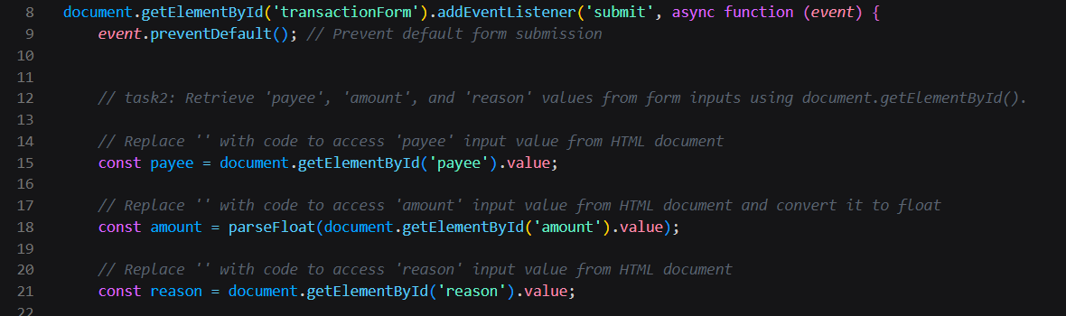

1. Locate the task3 comment and complete it.

This completes the 'newTransaction' object with 'id','payee', 'amount', and 'reason' properties.

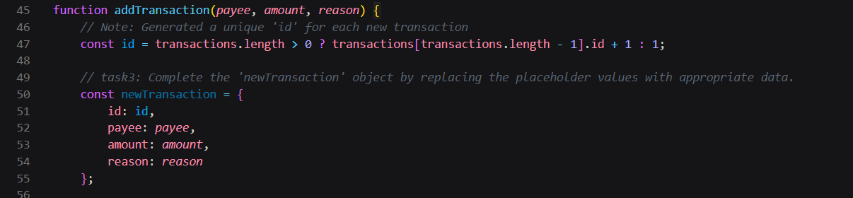

1. Locate the task4 comment and complete it.

This adds the 'newTransaction' object into the 'transactions' array using the 'push' method.



1. Locate the task5 comment and complete it.

This finds the transaction object in the 'transactions' array that

matches the provided 'id' parameter.



1. Locate the task6 comment and complete it.

This removes a transaction from the 'transactions' array by the

index value.

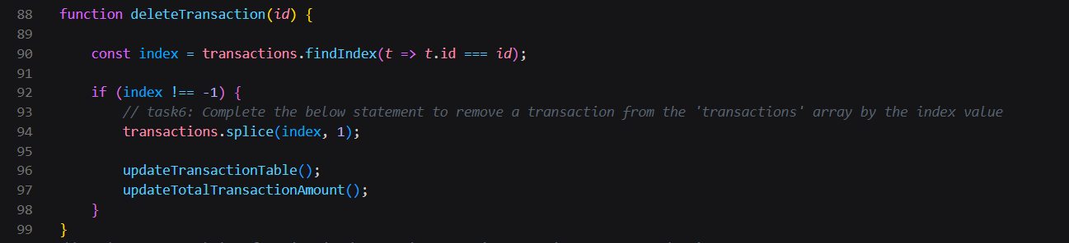

## Enhanced Task

1. Convert 'updateTotalTransactionAmount' to use **async/await**
   * Locate the **updateTotalTransactionAmount** function and convert it into an **async** function.
   * Look through all the script code and see where **updateTotalTransactionAmount** is called. Convert those calls to use **await** and ensure the calling function is marked as **async**.

